Re-shoring Manufacturing to the US: A Realistic View

President Joe Biden signed an executive order this that resulted in a review of supply chains by the government executive branch for pharmaceuticals, critical minerals, semiconductors and large capacity batteries. The 100-day review will be followed by a longer year-long review of a broader set of critical supply chains including the energy sector, personal protective equipment, agricultural products, the transportation industrial base and the public health and biological preparedness industrial base. “Today, I’m shortly going to be signing another executive order that’ll help address the vulnerabilities in our supply chains across additional critical sectors of our economy so that the American people are prepared to withstand any crisis and rely on ourselves,” Biden said before signing the Order.

Biden’s statement reveals a profound naivete of supply chains which is common in both politicians and the public. Most individuals’ understanding of the complexity of global supply chain designs is limited, and few realize that re-shoring all manufacturing back to the US with the flip of a switch (or the passing of an Executive Order) is impossible in the context of global trade. The Biden administration is suddenly concerned with re-designing supply chains, with the intention of ending the reliance on Chinese production, which could strengthen China’s competitiveness, especially in high tech areas, which could also lead to further national security issues around spyware, cybersecurity, and defense production. This in turn could not only threaten the US economic recovery following COVID, but also the national security and defense of the US in the future. We all recognize that our global supply chains which extend back to China are a concern. In fact a recent analysis by the S&P Market Intelligence group showed imports from China into the US are booming, and are 42% over what they were last year at the same time. So the US is still very reliant on “China.

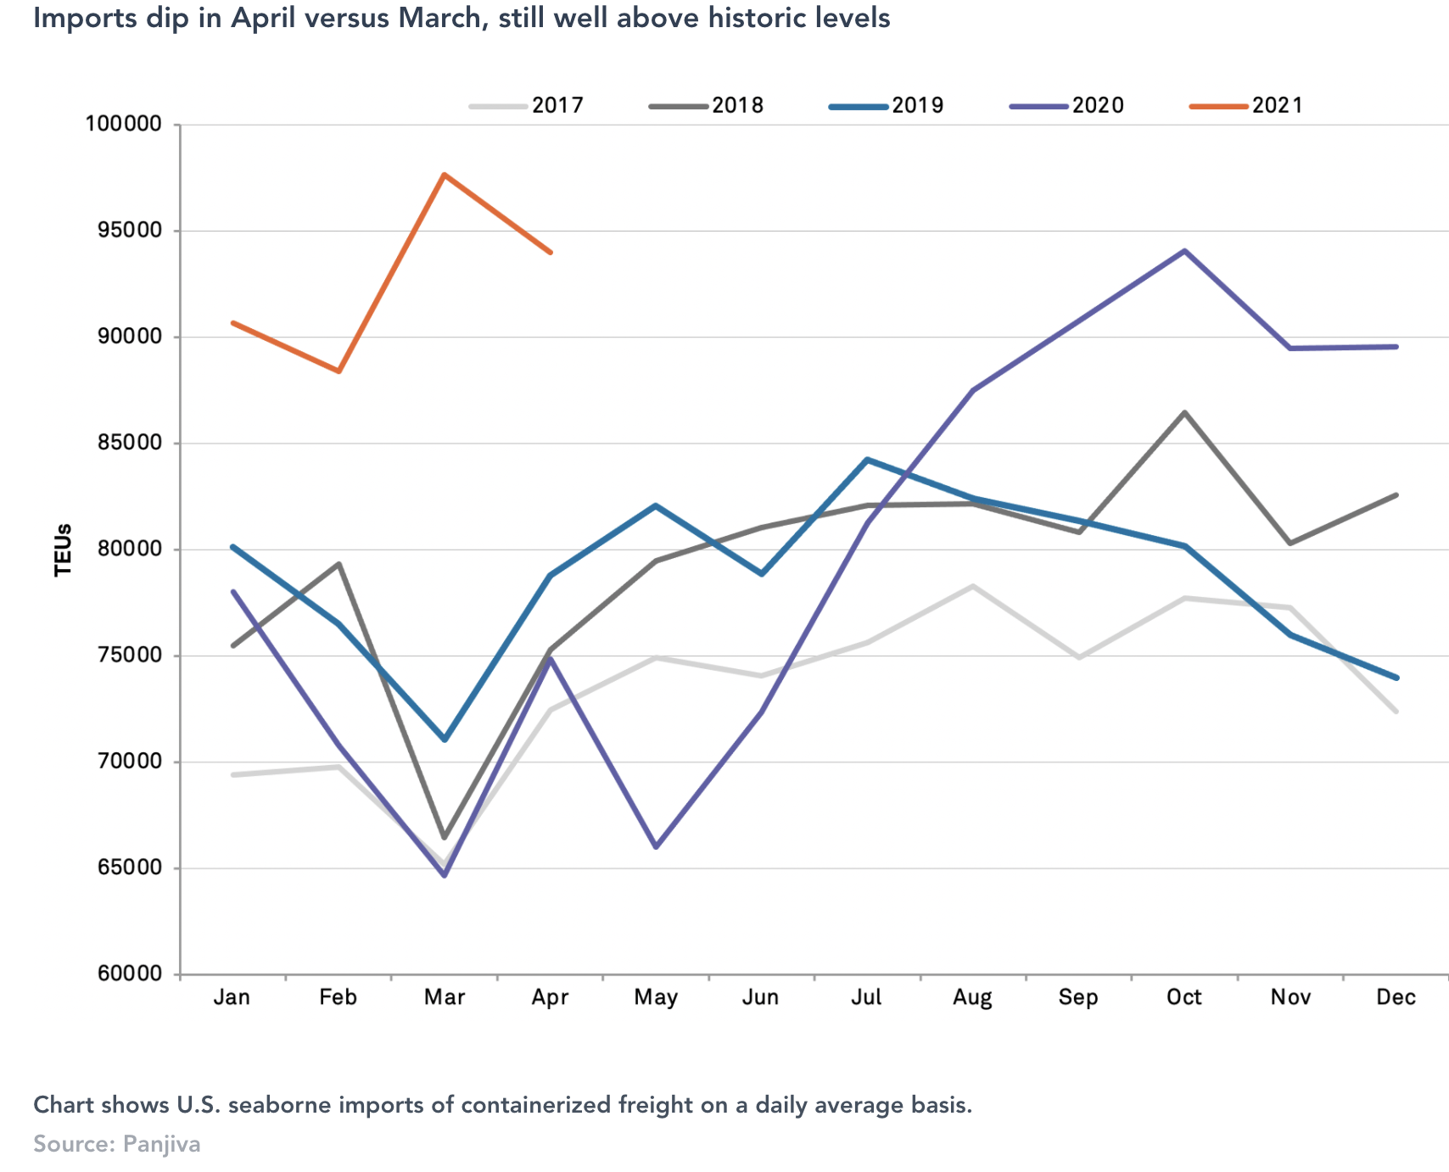

Biden’s call for re-shoring manufacturing back to the US will be a much more complex decision that the Biden Administration is letting on. We will need much more than 200 page reports from government bureaucrats to think through how to reduce our supply chain vulnerabilities. What is needed are a well-thought out set of policies, to help the US map out global supply chains to truly understand how to mitigate risk, where the primary sources of production are now firmly entrenched in Asia. It is going to be a much more complex set of tasks to think through the implications for government contracting, supply chain network design, total cost of ownership, and global trade policies.

There are problems with the idea of re-shoring manufacturing to the United States. My discussions with manufacturing executives suggest that once an organization commits to outsourcing to third parties in low-cost countries, there is a minimum planning horizon of five years involved, as this requires supplier qualification, audits, start-up, quality certification, and on-going ramp-up. In many industries, sourcing executives have embedded their supply chains in Asian regions, noting that “…these jobs will never return to Western countries.” As an example, 80% of the world’s production of certain medical products are produced by four manufacturers in one province in China. To establish alternative sources that are competitive, qualified, and at-scale would cost much more than the 25% in tariffs companies are paying today in the U.S. to import from China.

In my research I developed a framework of supply chain strategies for geopolitical risk mitigation (see Figure 1), which provides some guidelines to the federal supply chain on whether to adopt centralized/regionalized or localized supply chain designs according to how entrenched their suppliers are in a particular geographic location as well as how severe the geopolitical disruption is perceived to be.
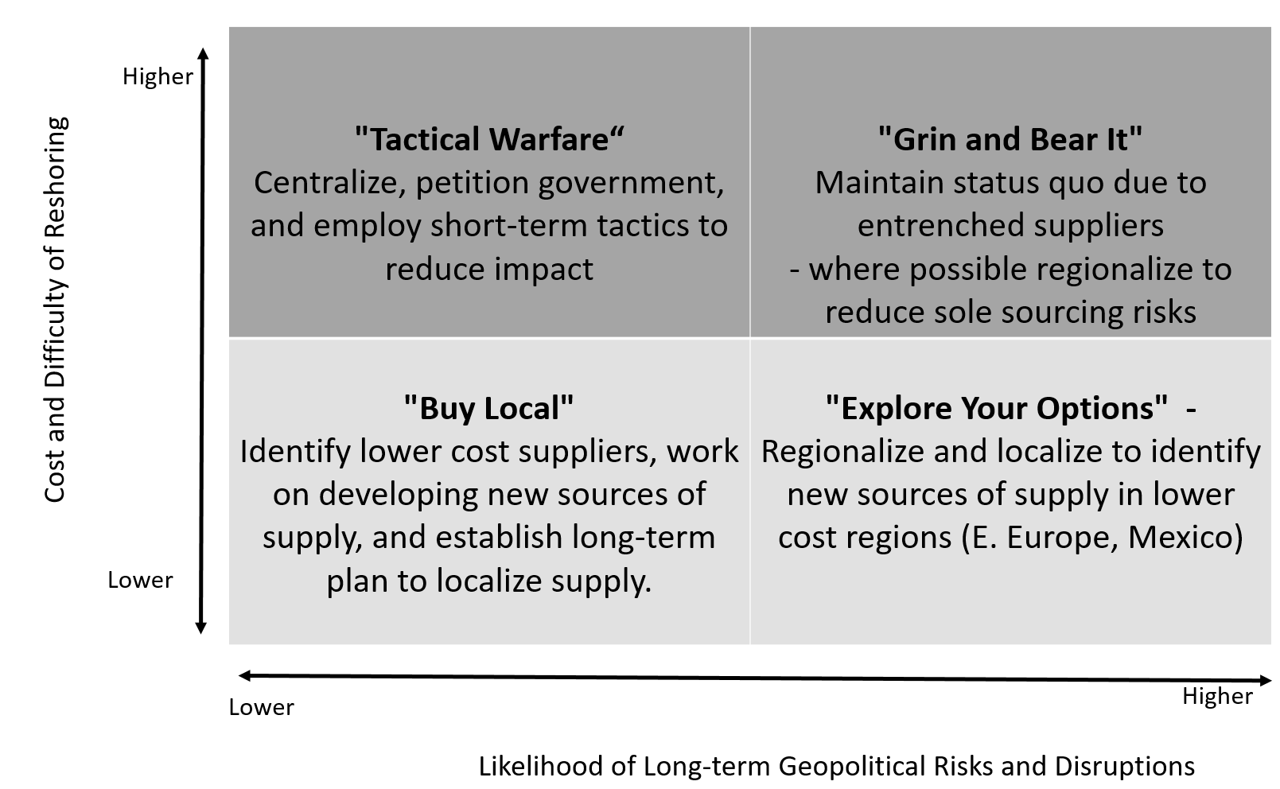
Figure 1: Framework for Supply Chain Strategies for Geopolitical Risk Mitigation
The Y-axis of Figure 1 shows the shifts in the external business environment, which have rendered it difficult to localize or shift the supply base, because of the entrenched nature of the supply base, or the cost-prohibitive elements for doing so. We note here that many Chinese industries were established with government investment, and the cost of capital for developing local sources is a significant barrier for investing in local supply capacity. The X-axis refers to the perceived likelihood of on-going political risk and disruption that is likely to continue, including the likelihood of on-going tariffs, customs duties, quotas, and export restrictions, resulting from a major and ongoing geopolitical event such as Brexit or the US-China trade war. In general, there are four strategies that emerge.

Strategy 1: “Grin and Bear It” - High difficulty of reshoring, High likelihood of on-going geopolitical risk. The increasing cost of moving products from an overseas supplier has been escalating, not just because of labor costs but also because of transportation costs, tariffs, duties, and supply discontinuity have dramatically increased the discussions around localization This perception has escalated following the COVID-19 crisis, as borders were suddenly shut down for critical materials like PPE and ventilators. However, there are some economic factors that simply cannot be overcome, where entrenched supply bases produce a “Grin-and-Bear-It” approach. This approach recognizes that in some industries, supply chain redesign is difficult, if not impossible, such as in the electronics industry where the epicenter of component manufacturing and final assembly is in Asia. Under the “Grin-and-Bear-It” approach, we suggest companies will prioritize short-term tactical efforts such as building redundancies and holding inventory at different points in the supply chain. Other tactical strategies may include moving production to nearby locations (such as Vietnam) or transshipping through nearby locations to allow for a change in the country of origin customs label and the avoidance of tariffs.

Strategy 2: “Explore Your Options”- Low difficulty of reshoring, High likelihood of on-going geopolitical risk. The movement towards localization strategies is a function of the supply chain logics that prioritize the avoidance of uncertainty and risk, and an acknowledgment of the importance of lowering the total landed costs of goods, which occurs naturally as suppliers are located closer to customers. Localization is particularly relevant due to the size/cost ratio of goods with large, bulky, and low-margin items (such as food and beverages, vehicles, fabrications) being manufactured closer to the point of consumption because they are expensive to transport. There is also an opportunity to increase domestic sourcing to exploit local market knowledge and drive growth. Consider the case of mobile phone technology and how local producers in India and China have taken massive market share by moving towards regional supply chains that produce locally for local markets. Proximity drives lower costs by being closer to customers and closer to the point of sale. For the same reason, Amazon is opening Distribution Centers close to major centers of demand in the United States, with many US retailers moving to a same-day or next-day logistics delivery model.

Strategy 3: “Tactical Warfare”- High difficulty of reshoring, Lower likelihood of on-going geopolitical risk. For some products, such as pharmaceuticals, medical supplies, healthcare products, and complex tooling, we may see reduced tariff barriers as access to these products is deemed critical following the COVID crisis. For instance, we are unlikely to see a sudden surge of local production of high volume, low-cost medical products in Western economies. For products within this quadrant, the expectation is that geopolitical risks will not be ongoing, with such risks not perceived as being not substantial enough to justify the cost of relocating production. Companies in this quadrant will adopt short-term tactical measures such as tariff avoidance, regional distribution centers with inventory, and national stockpiles of goods. However, if there is maintained political pressure for these types of goods to be produced locally, such as pharmaceuticals to treat the symptoms of COVID-19 or PPE, these industries will consider shifting production on-shore. In addition, we may see manufacturing, heavy engineering, and oil and gas seek to develop local suppliers of engineered products, to ensure business continuity and develop secondary sources of supply, even though costs may increase.

Strategy 4: “Buy Local” - Low difficulty of reshoring, Low likelihood of on-going geopolitical risk. For those products that are subject to local cultural differentiation and local sources of supply, we will see localized supply chain designs dominate, with this category expected to grow further as consumer demand for local products increases. Industries in this sector include food, especially fresh fruit, vegetables, and meat, as well as complex health products such as customized pharmaceutical products (gene therapies) and ventilators. For example, we are beginning to observe new start-up companies in areas such as customized apparel, who are seeking to develop digital apparel production capabilities in response to consumers who are seeking customized clothing and want it delivered within 48 hours, and localized capabilities will become important for this sector. We now map the industries in our study to the four strategies shown in Figure 1 to provide an indicative framework for supply chain designs (see Figure 2).
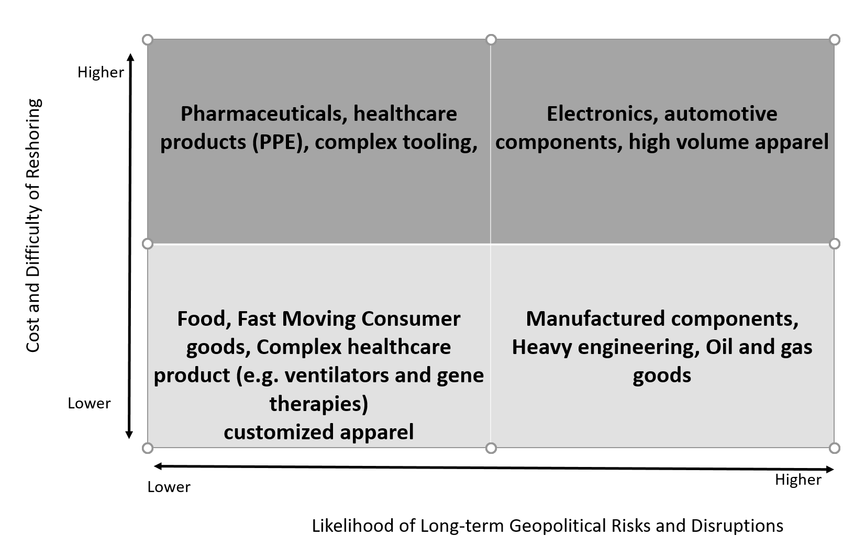
Figure 2: Indicative mapping of supply chain risk mitigation strategies by industry

This is an indicator of how I believe the likelihood of shifting global supply chain designs will play out over the next five years. It will be an interesting time, as the Chinese proverb says.

